4. Write sample skeleton of pipelines.
Scripted Pipeline (Jenkins - Skeleton) node.
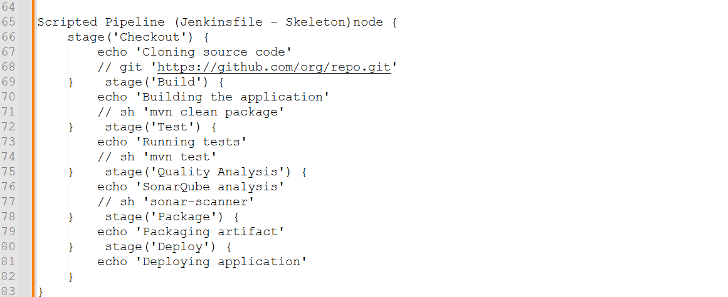
Declarative Pipeline (Jenkinsfile - Skeleton)
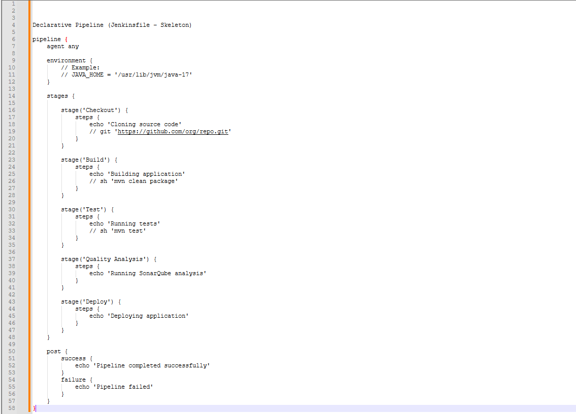
Conclusion for scripted:
Scripted pipeline uses Groovy scripting and provides more flexibility and control.

5.Create a parameterized job in Jenkins.
https://github.com/betawins/spring3-mvc-maven-xml-hello-world-1.git
Step 1: Open Jenkins Dashboard
- Open Jenkins in your browser.
- Log in with admin credentials.
- From the dashboard, click New Item.
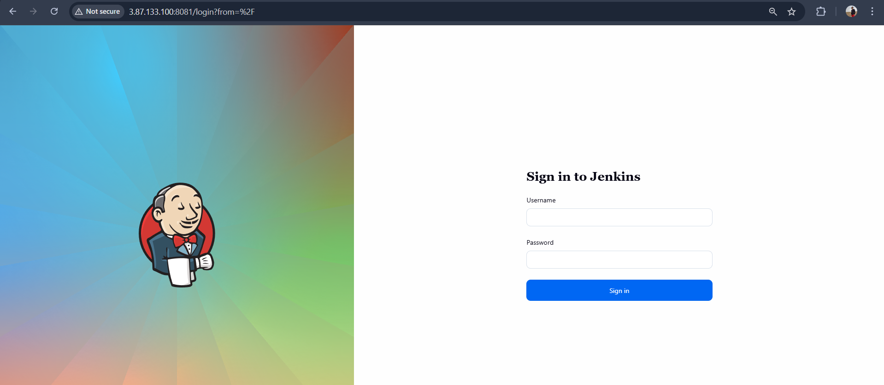
Step 2: Create a New Job
- Enter job name:
parameterized-job
- Select Freestyle project.
- Click OK.
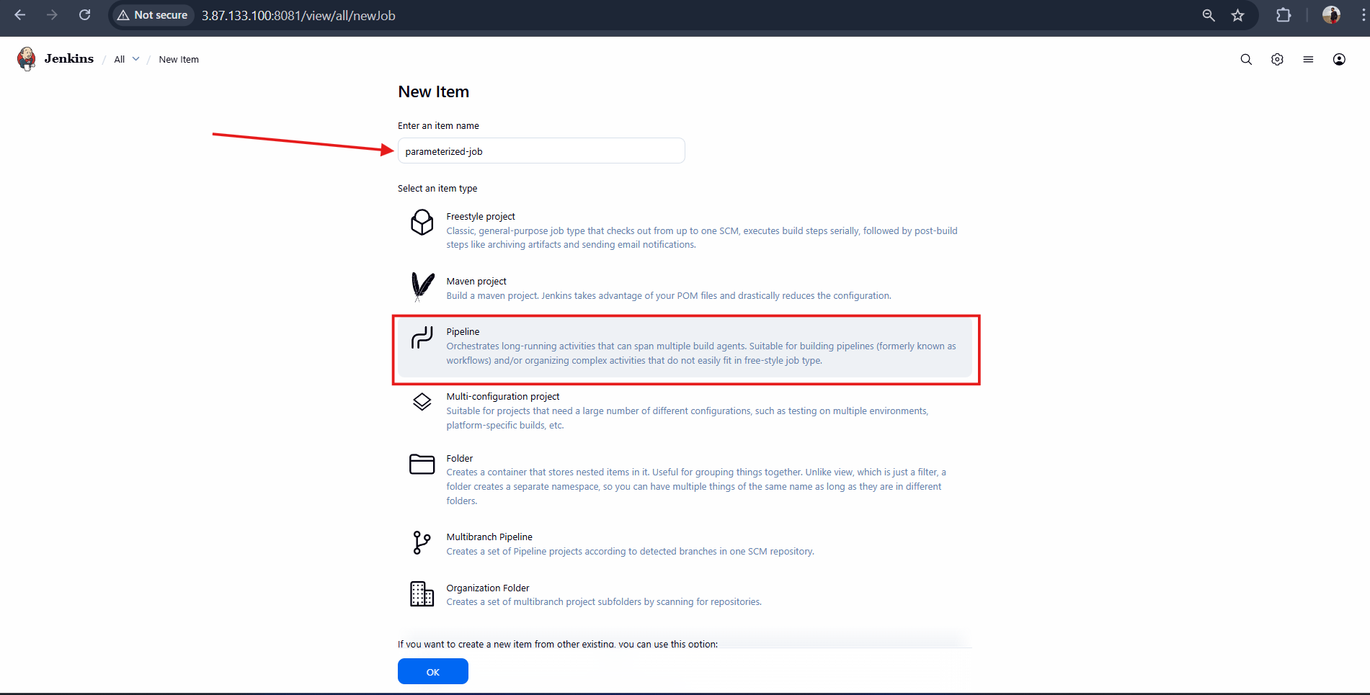
Step 3: Add Parameters in Jenkins
- Go to Jenkins Dashboard → Your Job → Configure.
- Check This project is parameterized.
- Add the following parameters:
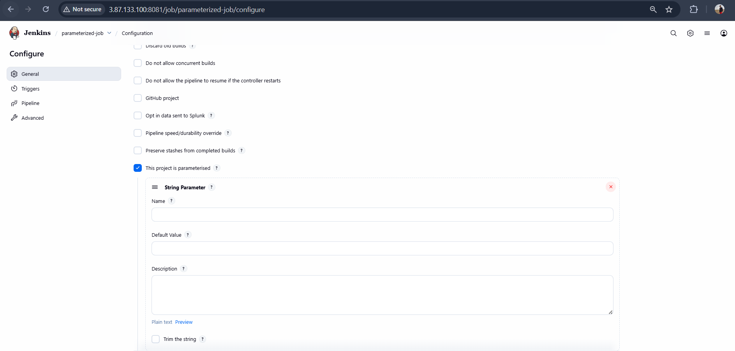

Step 4: String Parameter
Name: BRANCH
o Default Value: master
o Descrip6on: Git branch to build
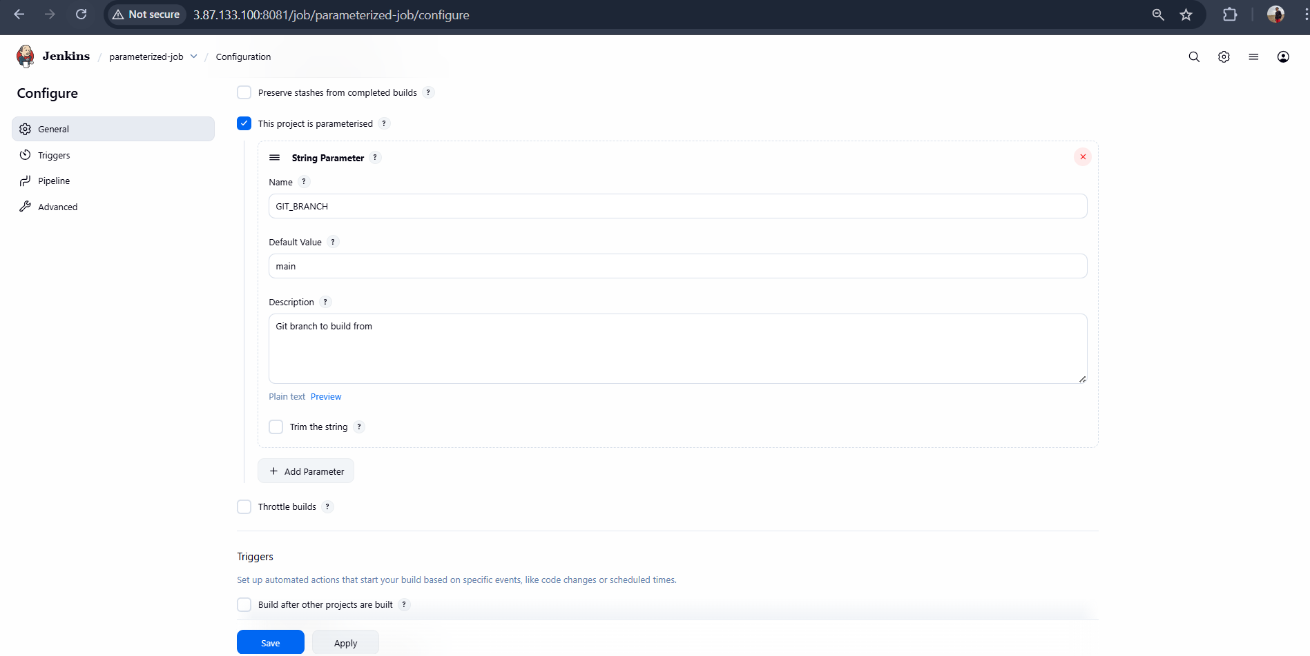

Step: 5 String Parameter
Name: MVN_BUILD
Check Set by Default
Descrip6on: Run Maven build
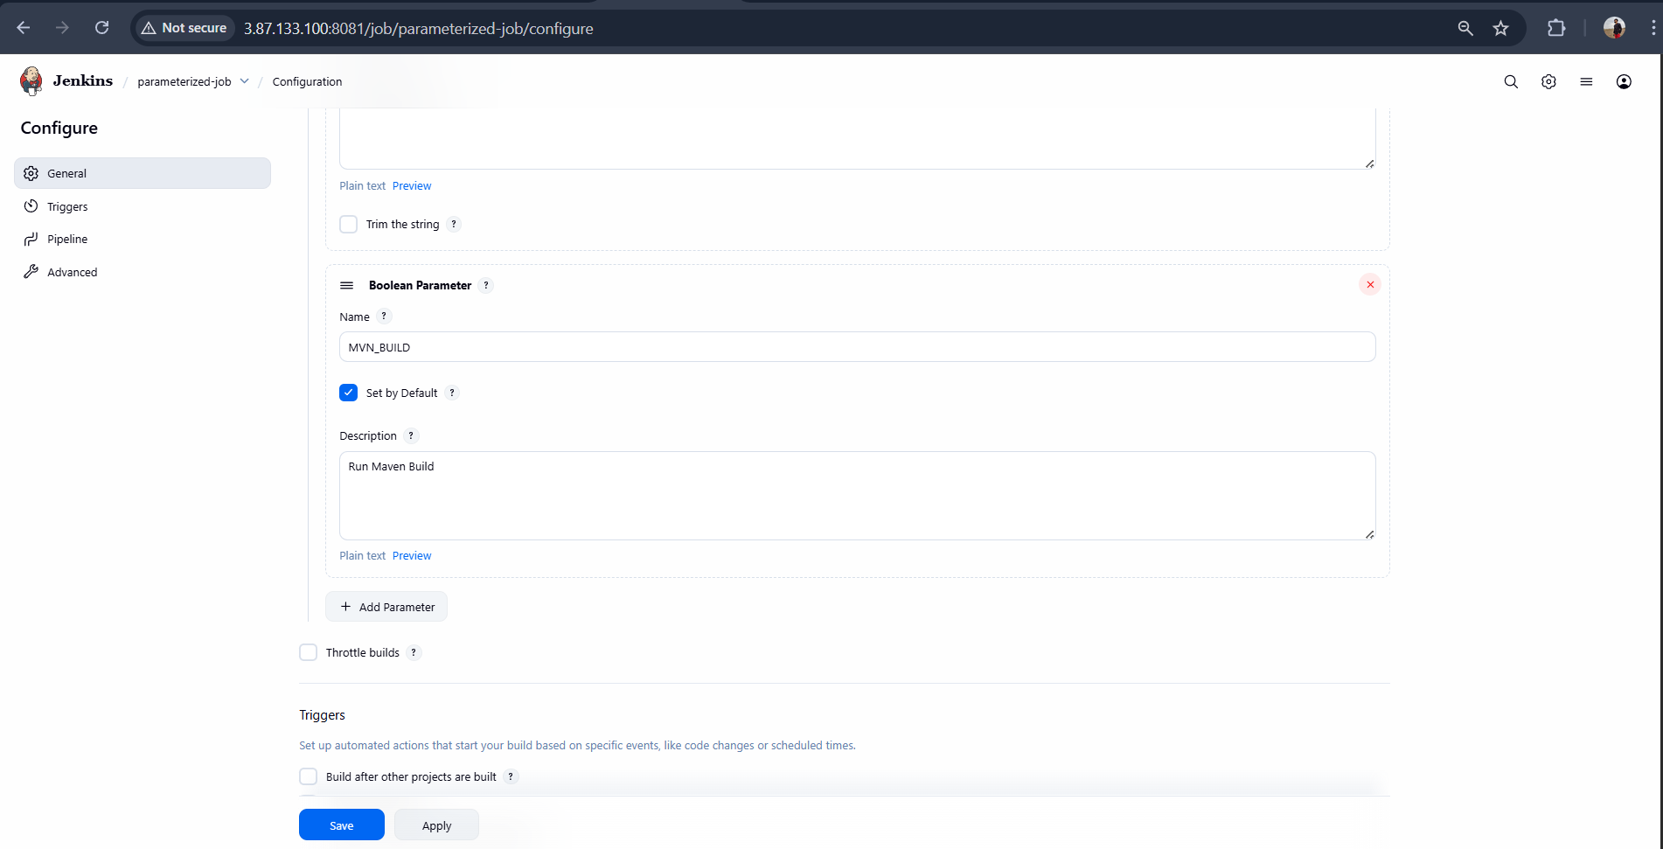

Updated Scripted Pipeline Code
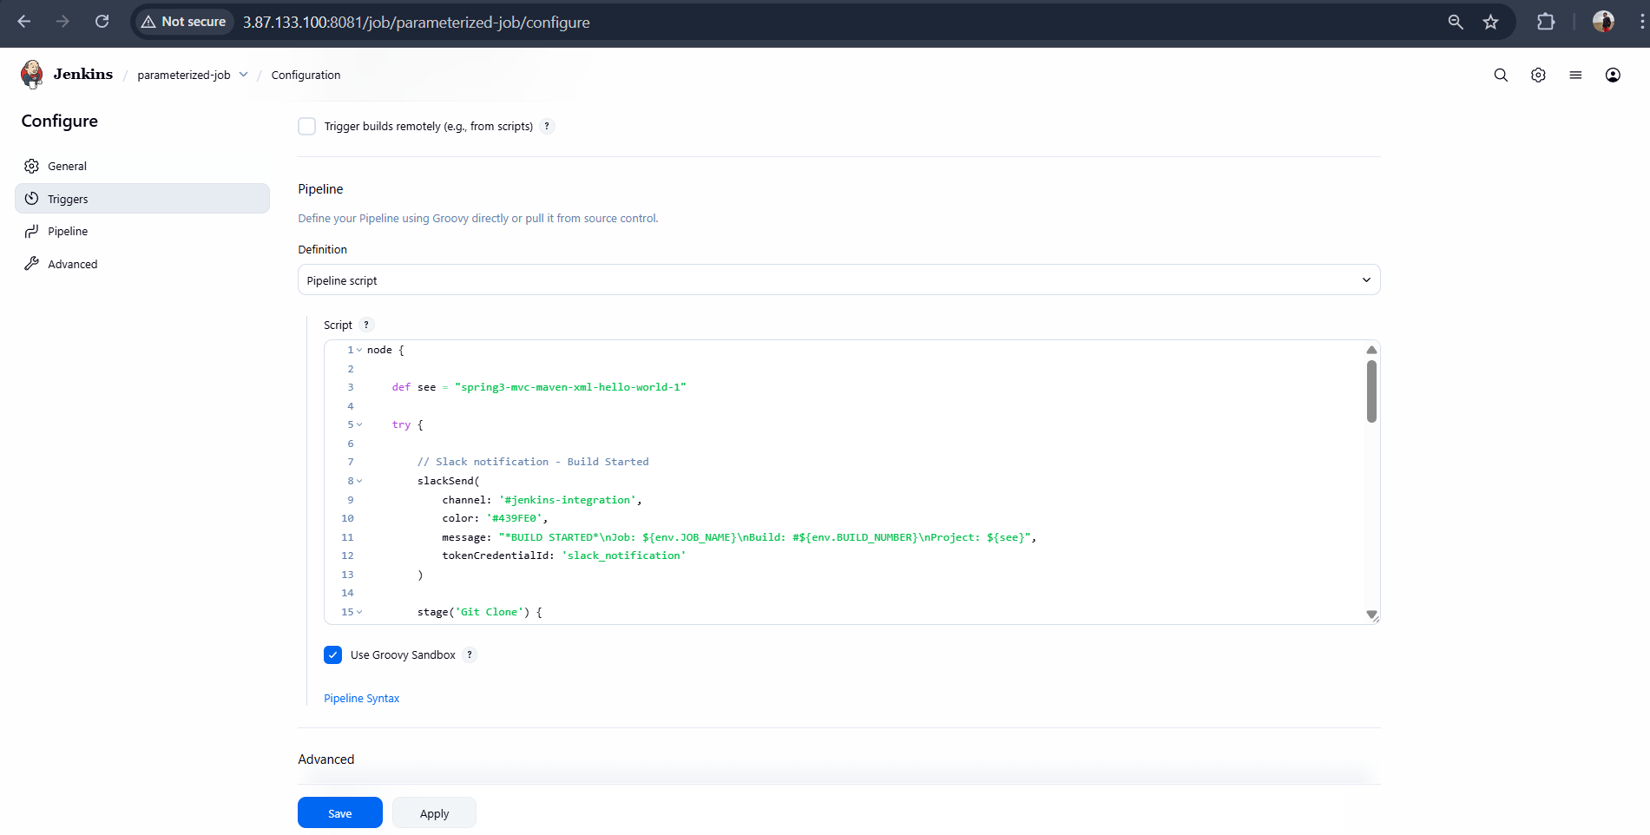

Save and Build with Parameter

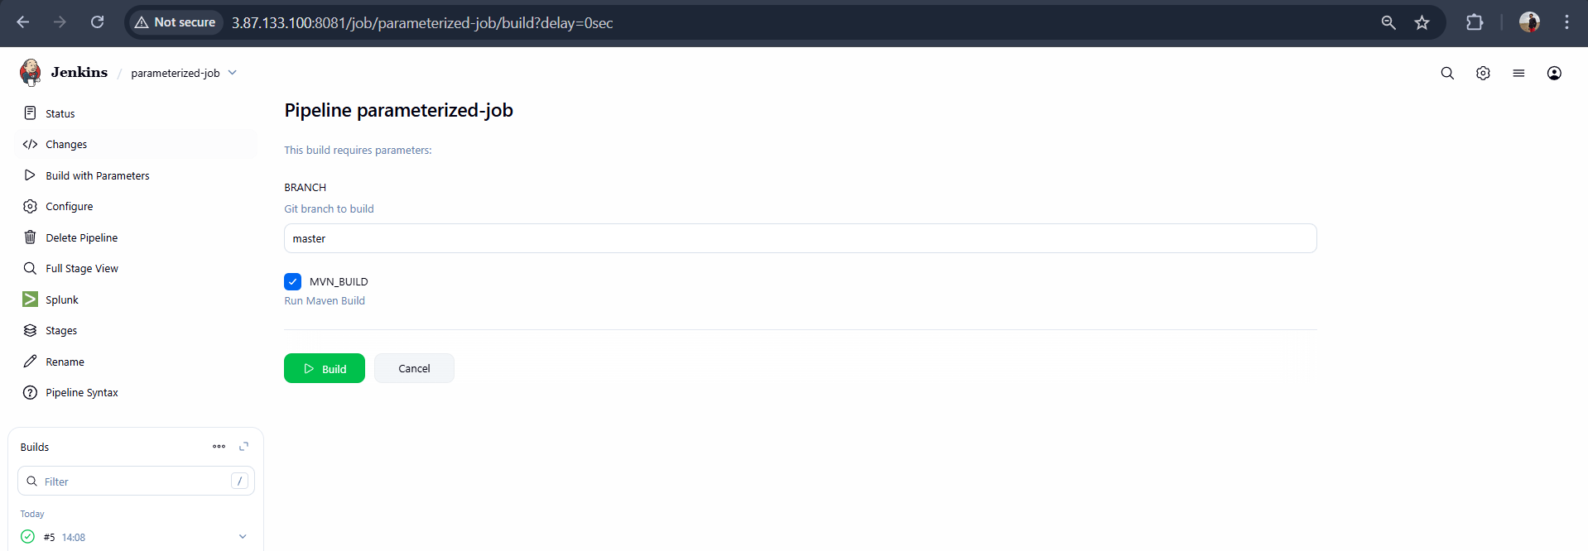

Slack Notification :
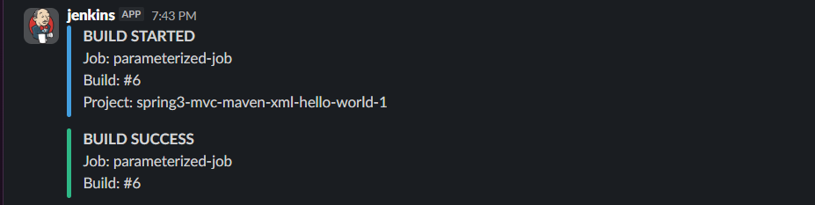

Validation: Pipeline view
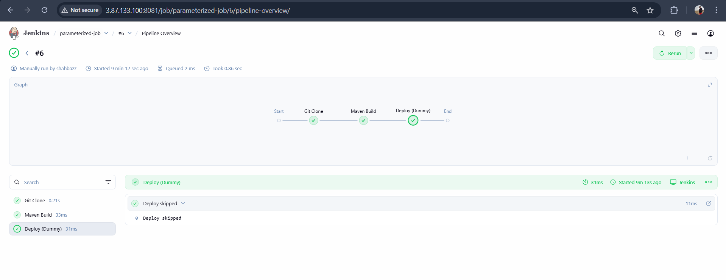

Validation: Stage view
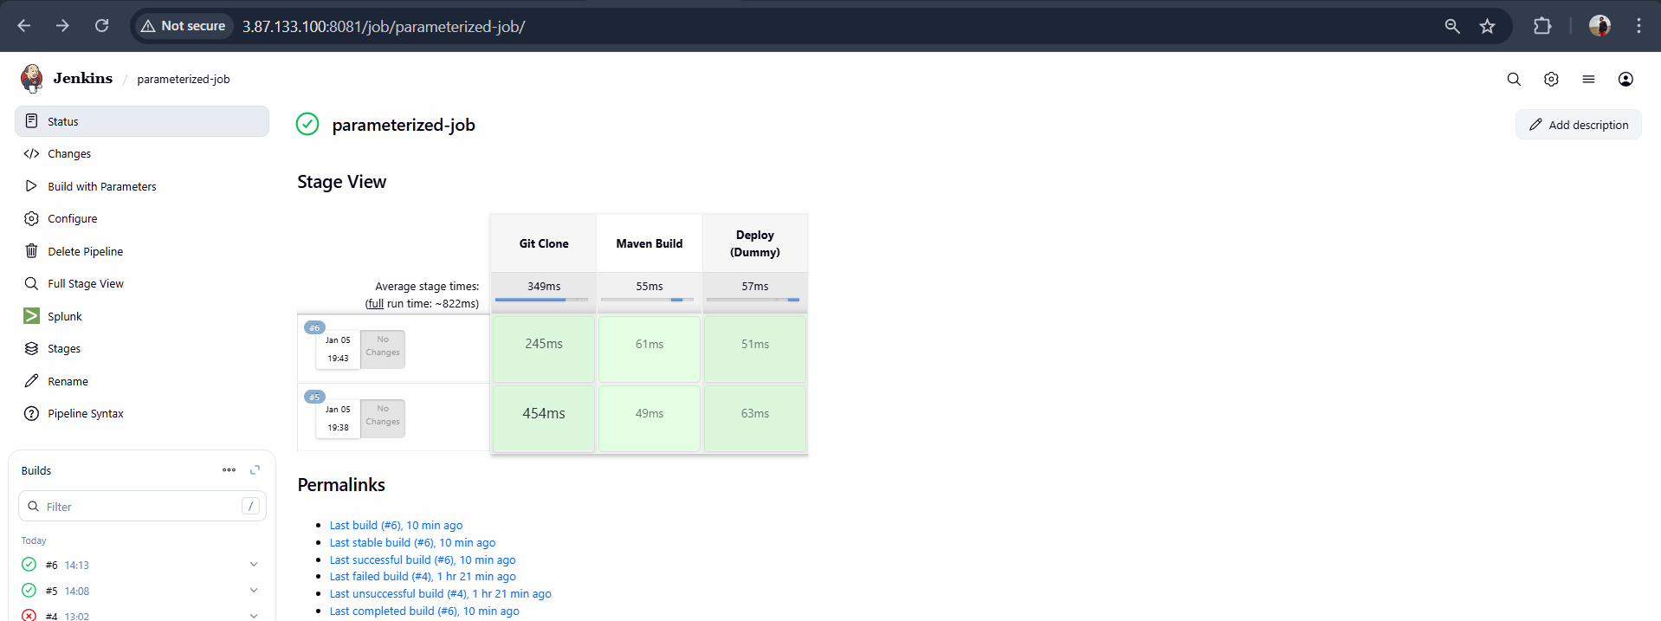

6. Setup one slave machine for Jenkins.
Jenkins Master–Slave Configura3on
Steps to be done on slave
Step-1 : Create an ec2 –slave
Login to slave machine..
Install Java on slave
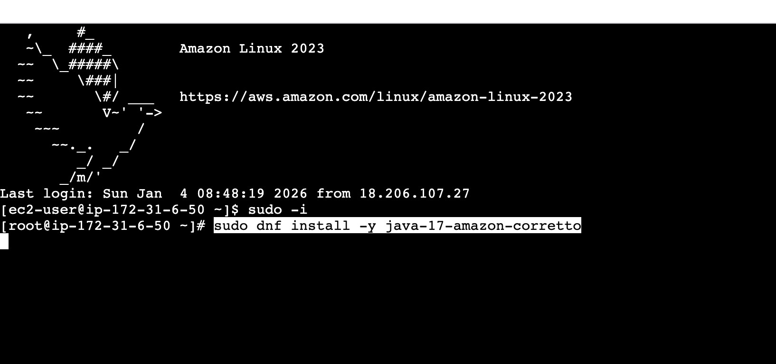
sudo dnf install -y java-17-amazon-corre
T
o

Check the java version
Java –version
Create a folder jenkinsremote folder
And give permissions to that folder Chmod 777 jenkinsremote and Copy the pwd /home/ec2-user/jenkinsremote
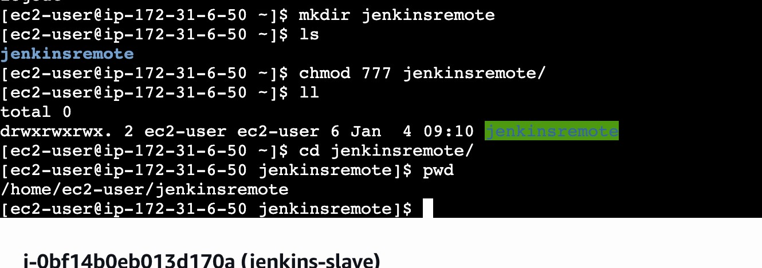

Configure Node in Jenkins Master
- Go to Jenkins Dashboard → Manage Jenkins → Nodes and Clouds → New Node
- Enter node name (e.g., slave-1) → Select Permanent Agent → OK
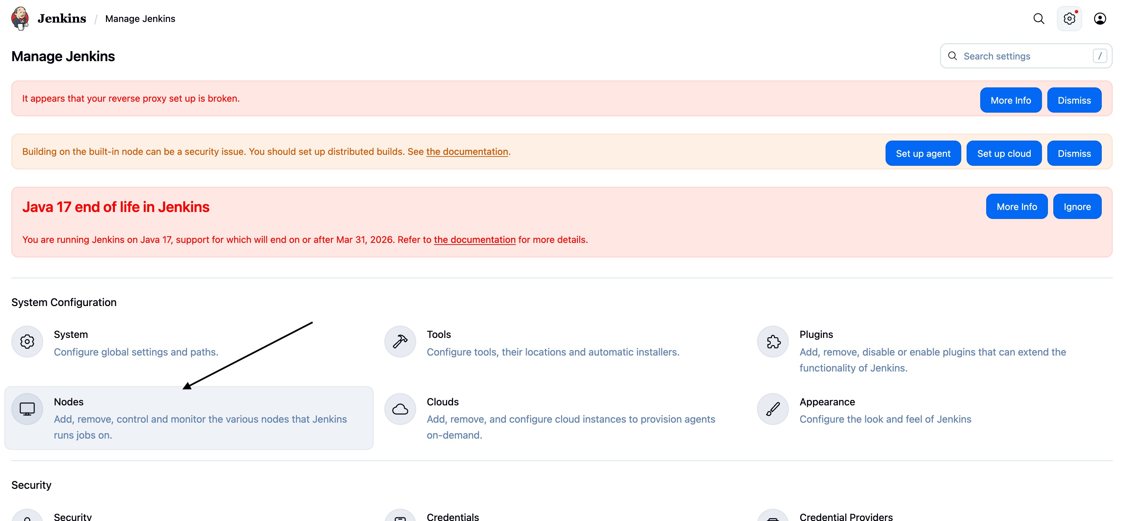

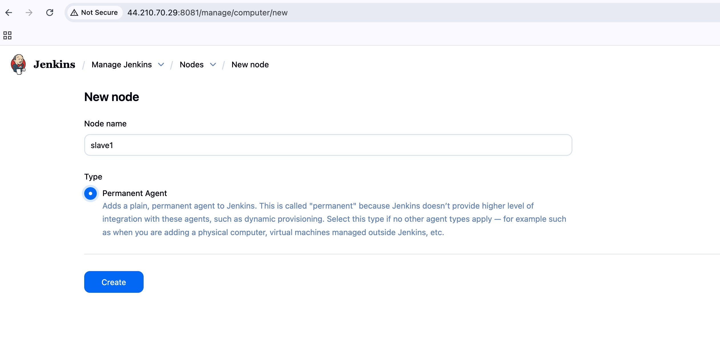

- Configure:
  - Remote root directory: (/home/ec2-user/jenkinsremote)
  - Labels: give a label (e.g., _{linux}, _{build}) to target jobs ( I have given java ) o Number of executors → usually 1 (how many jobs can run in parallel on this agent).

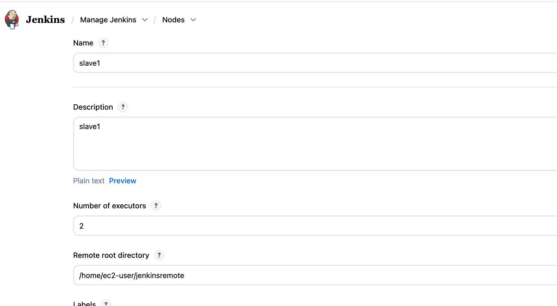
Add creden6als (Jenkins user SSH key)
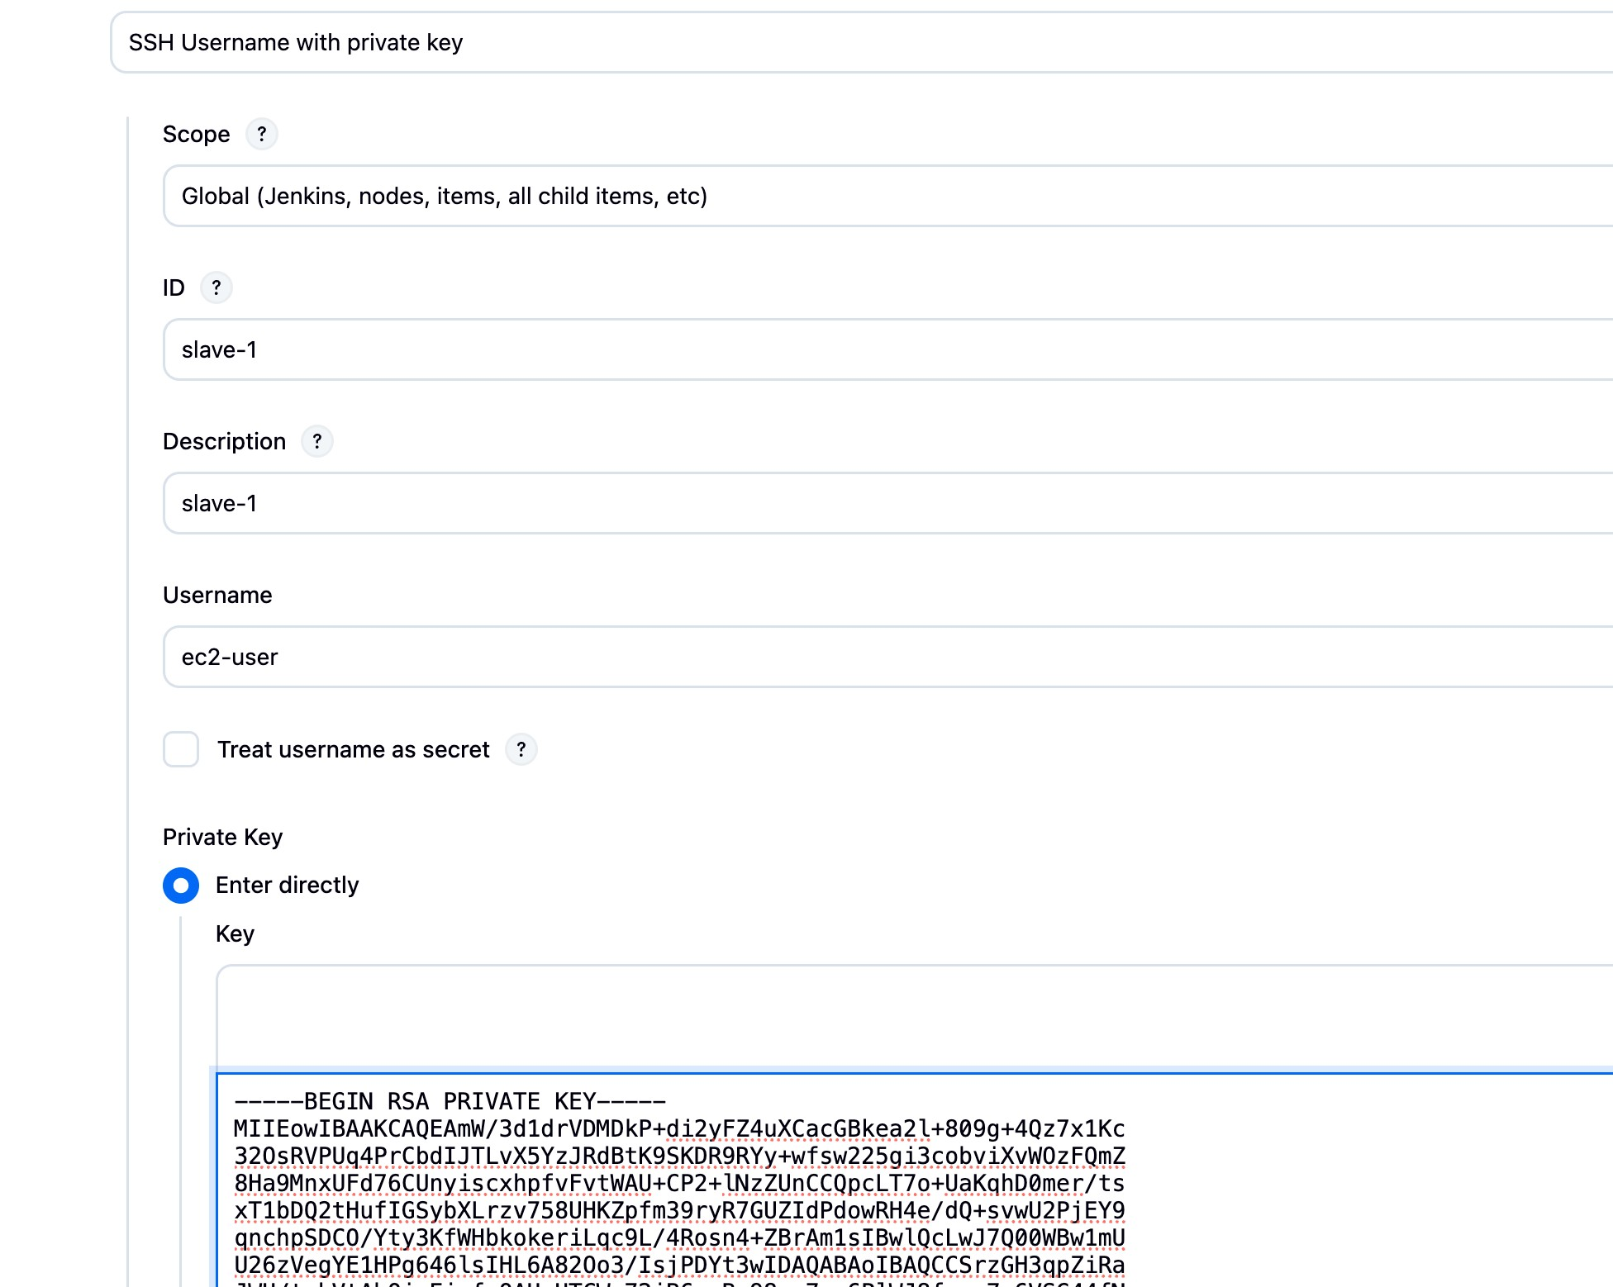
Now go to node configuration and add launch agent ssh
Enter public /IP of ec2 slave
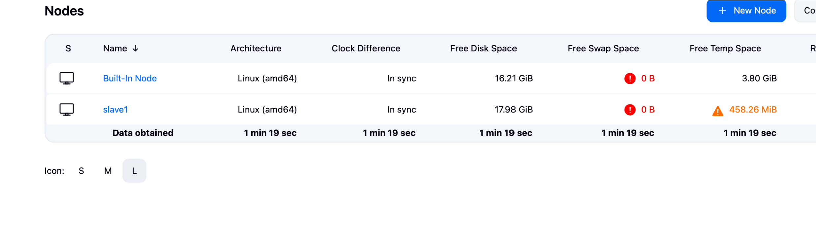
OR Launch agent via Java Web Start (JNLP) if SSH not possible
•
If successful, node shows as
online
.

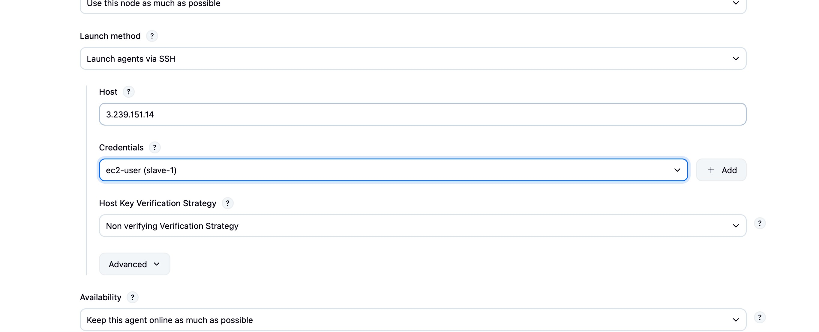
Usage
→ Choose
Use this node as much as possible
.

Modify the disk space threhold
Test Connec6on
- Click Save → Jenkins will try to connect.
- Check node status in Build Executor Status (boTom le{).
—> check log
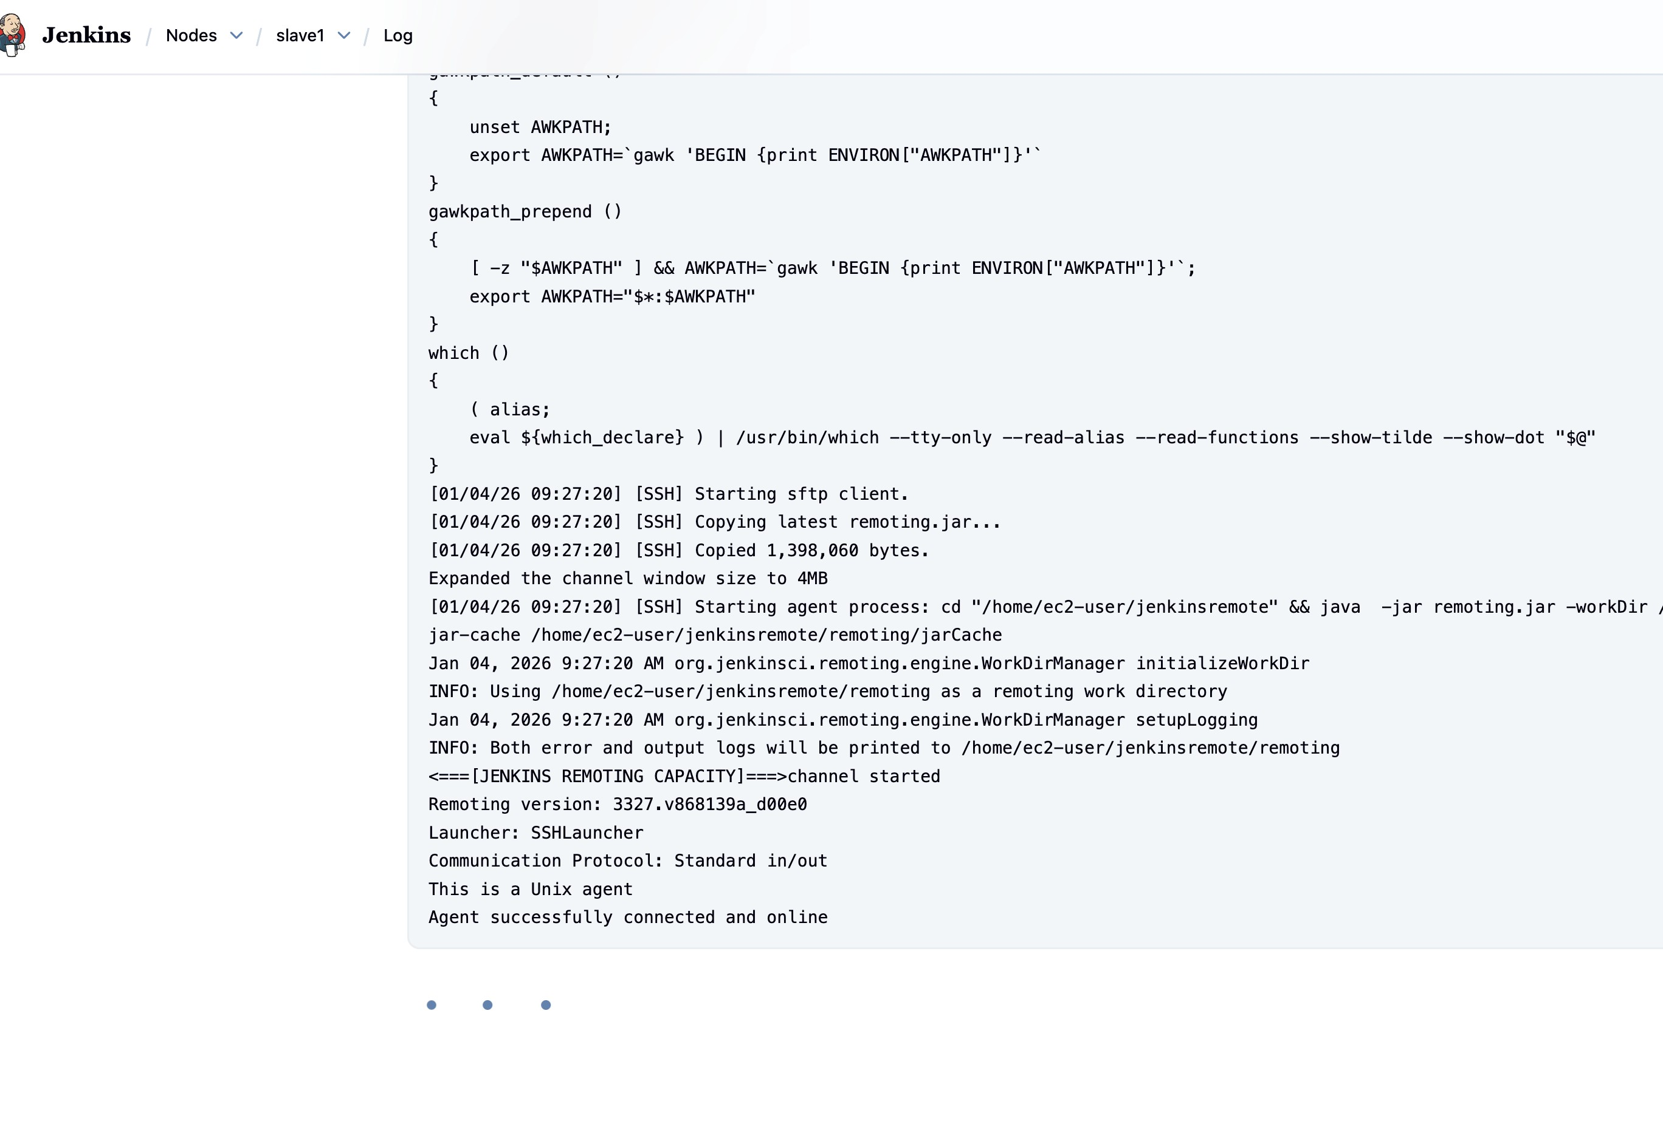

Create a simple job and restrict it to the new agent by label.

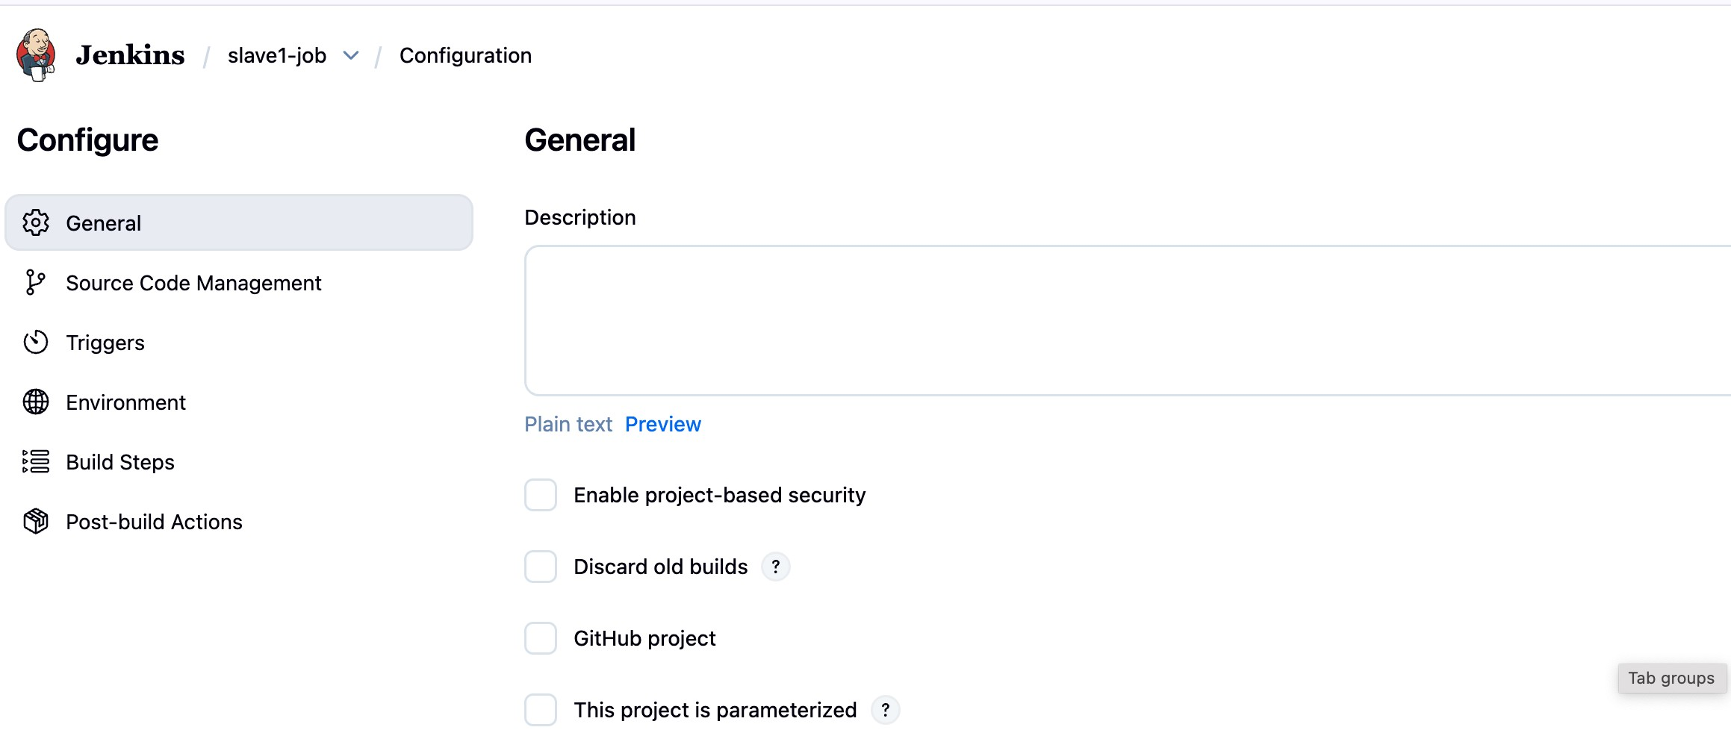
Give restrict where this project can be run
In label expression give java
and click save
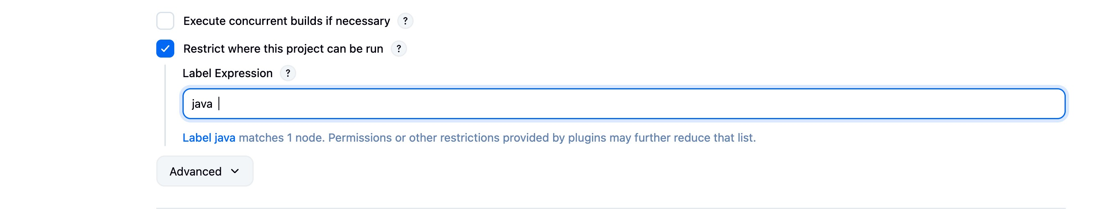

Now click build now and check the log status

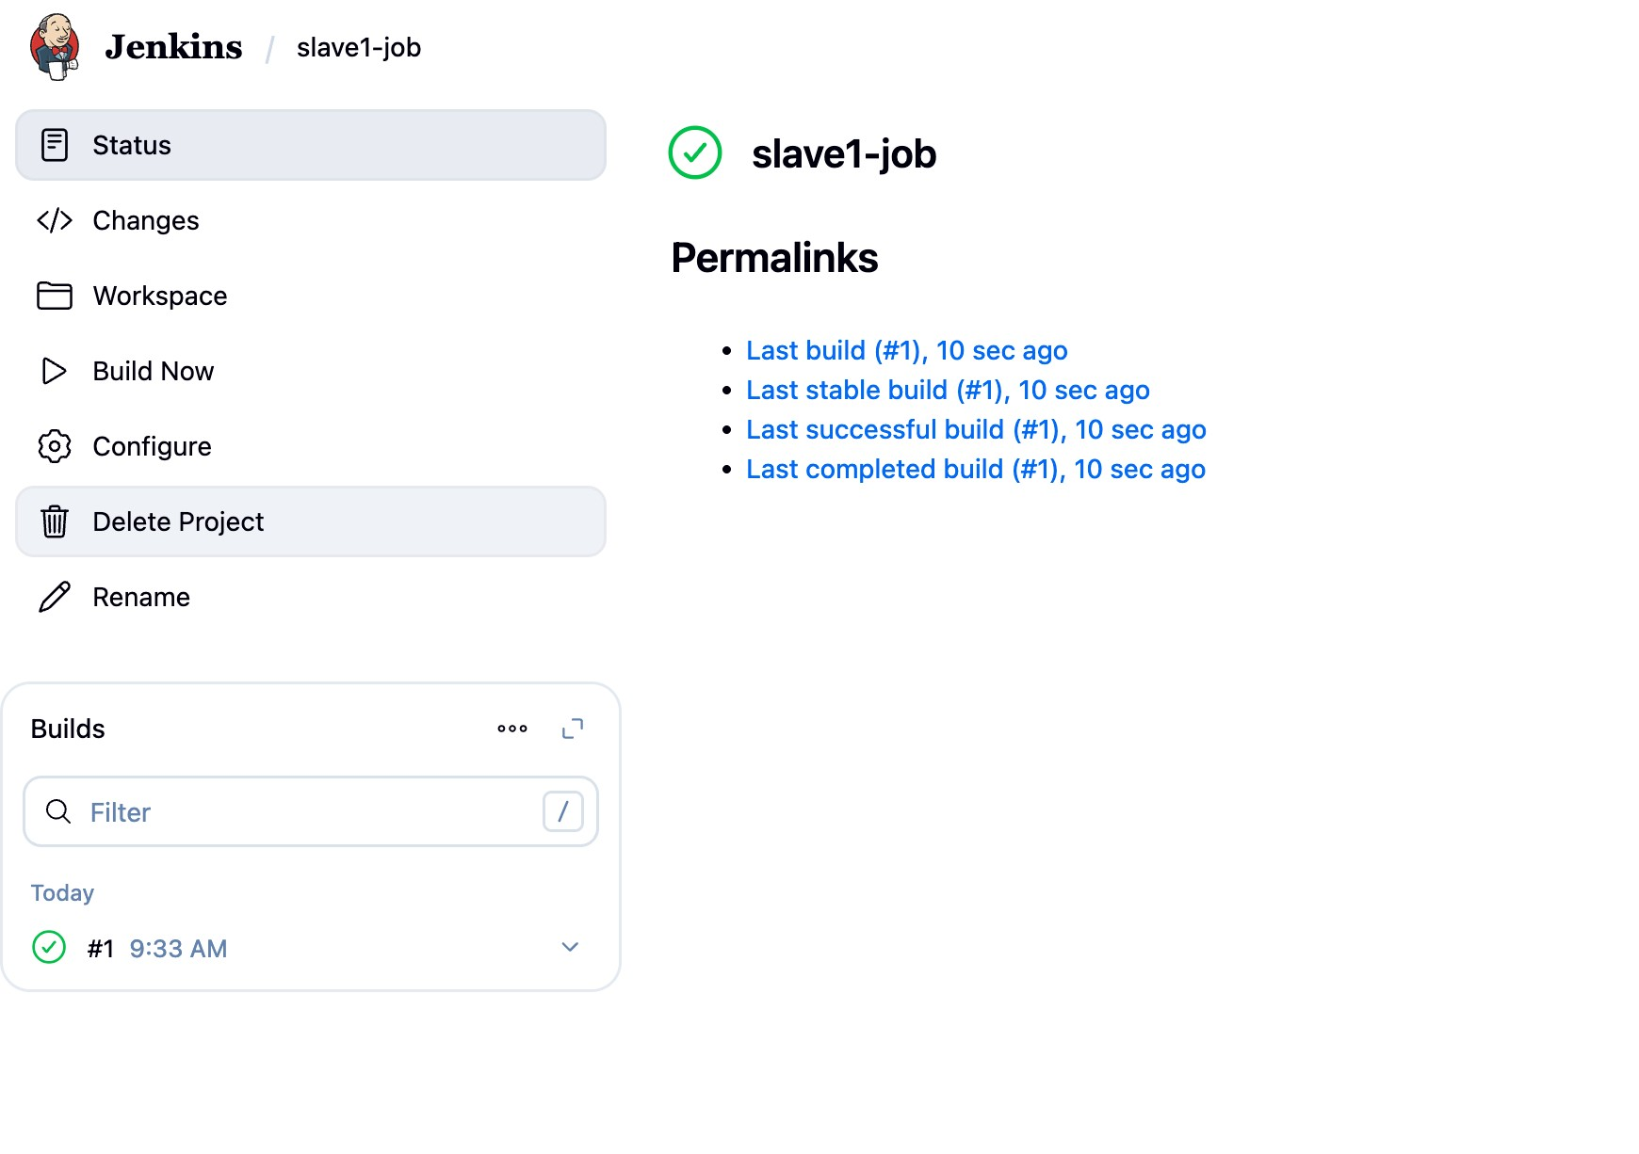
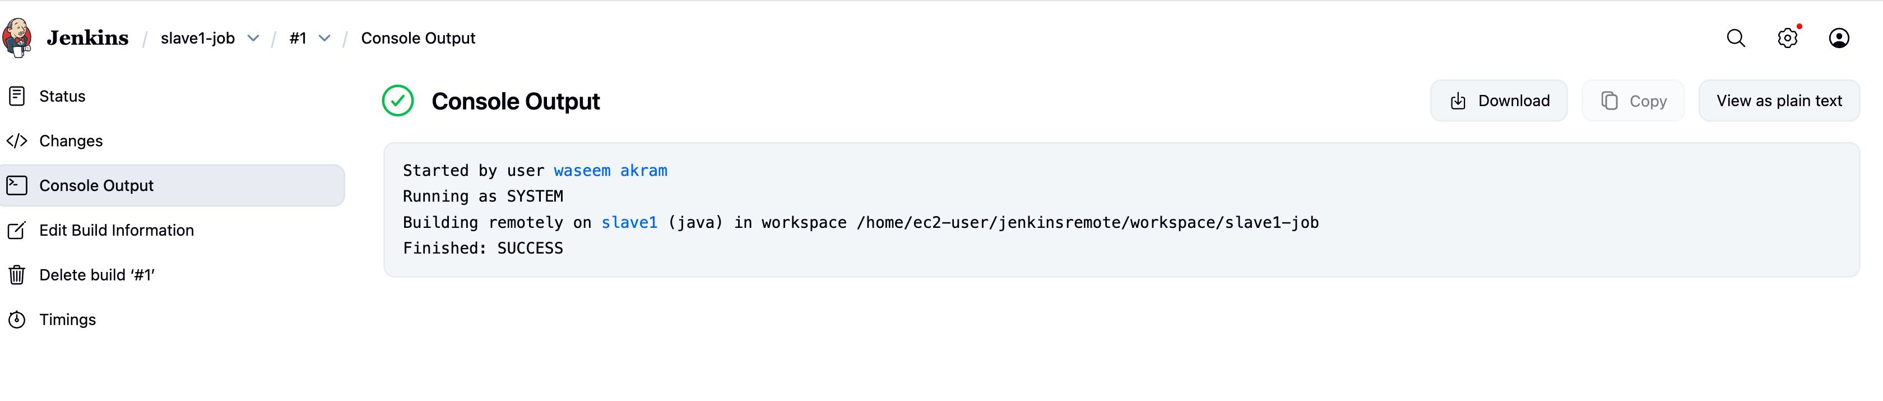

by this Jenkins slave is connected

